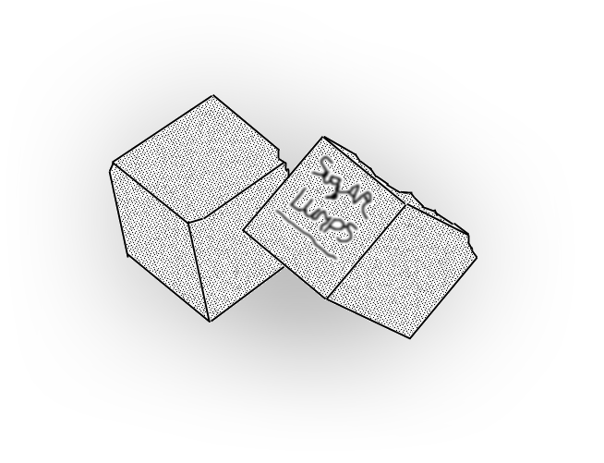

**Design Document for:**

# Jacco's helicopter game

**One Liner, i.e. The Ultimate Racing Game**

“the best team of them all”™

All work Copyright ©2007 by Sugerlumps

Written by Mike van Mourik

Version # 1.10

Wednesday, October 23, 2013

Table of Contents

Jacco's helicopter game 1

Design History 4

Version 1.1 4

Version 1.0 4

1. Introduction 5

1.1 Philosophy 5

1.2 Common Questions 5

1.2.1 What is the game? 5

1.2.2 Why create this game? 5

1.2.3 Where does the game take place? 5

1.2.4 What do I control? 5

1.2.6 What is the main focus? 5

1.2.7 What’s different? 5

2.0 Feature Set 6

2.1 General Features 6

2.2 Editor 6

2.3 Gameplay 6

3.0 The Game World 7

3.1 overview 7

3.2 world environment 8

3.2.1 Gamelab-top 8

3.2.2 Gamelab-bottom 8

3.2.3 Key Locations 8

3.2.4 Scale 8

3.2.5 Objects 8

3.2.7 Time 9

3.3.0 Rendering System 9

3.3.1 Overview 9

3.4 Cameras 9

3.4.1 Overview 9

3.4.2 Story-mode camera 9

3.4.3 Instruction-mode camera 9

3.4.4 Game-mode camera 9

3.4.5 Tutorial-mode camera 10

3.4.6 Zoom camera 10

3.5 Game Engine 10

4.0 The World Layout 11

4.1 Overview 11

4.2 Gamelab ground floor 11

4.3 Gamelab first floor 12

5.0 Game Characters 13

5.1 Overview 13

5.2 the main Character 13

5.3 Enemies and Monsters 13

6.0 User Interface 16

6.1 Overview 16

6.2 Instruction/Tutorial monitors 16

6.3 Led indicator 16

6.4 Smoke and fire 16

6.5 Laser colour 16

6.6 menus 17

7.0 Weapons 18

7.1 Overview 18

7.2 Coffee Canon (the C C ) 18

7.3 Laser gun 18

7.4 Staple gun 18

8.0 Musical Scores and Sound Effects 19

8.1 Overview 19

8.2 Music 19

8.3 Sound effects 19

9.0 Main Game aspects 20

9.1 Overview 20

9.2 Story( a more detailed description is found in the story appendix ) 20

“Story Appendix” 21

# Design History

This is a brief explanation of the history of this document.

## Version 1.1

1. Story and world layout where added

Because it was not in there yet

1. Staple gun added

Gun added after discussion about weapons system

1. Weapons & ammo pickup rewritten

Gun added after discussion about weapons system

1. Music added

Because it was not in there yet

1. Updated feature list

Needed to be updated allot was missing

## Version 1.0

Version 1.0 – initial game design

1. the initial game design was created
2. changed jumpers to just jump with themselves instead of a team

this because the original idea was to hard to design and integrate

1. changed soldiers to use there grown stinger instead of there front legs

this because the original design was not cool enough

1. added laser levels

because they where missing

# 1. Introduction

## 1.1 Philosophy

This Game will combine the toy helicopter game elements with that of the Ant Wars game. Combining these two games together will create a fun and challenging game that has combined the fun of controlling a toy helicopter with the objective and mission style game play of a Ant Wars game.

## 1.2 Common Questions

### 1.2.1 What is the game?

This game will be an action helicopter shooter game, set in the Gamelab of the Blushuis.

The player will find himself in the shoes of Jacco Bikker a teacher at the IGAD course. Armed with his trusty toy helicopter the player will have to fight the mutated ants that are attacking Gamelab because of the great electrical power that’s used by the computers there.

### 1.2.2 Why create this game?

We decided to create this game because it would be fun to bring the Ant Wars and the helicopter game elements together. Since most toy based games are not focused on completing objectives we decided it would be a great idea to give the player an enemy that they can fight instead of a racetrack or time attack race they have to complete.

### 1.2.3 Where does the game take place?

This game takes place in the Gamelab class room of the Blushuis. This is the computer room and teacher room of the IGAD course at the NHTV.

### 1.2.4 What do I control?

The player will be playing as Jacco Bikker a teacher at the IGAD course of the NHTV. The player does not control Jacco himself, but will be controlling the toy helicopter.

**1.2.5 How many characters do I control?**

The player will only have control over a toy helicopter that the character Jacco is controlling

### 1.2.6 What is the main focus?

The player will get objectives that will lead to the destruction of the mutated ants. Using the toy helicopter the player will have to complete several objectives that will get him closer and closer to saving the course from a mutated ant attack. These objectives (described further in the document) can vary from attacking the ants that are coming up from the stairs to deactivating the air-conditioning system(for clearing fly path).

### 1.2.7 What’s different?

This game will have objectives and is focused on completing a mission instead of most toy based games that mostly use track racing and time attacks.

# 2.0 Feature Set

## 2.1 General Features

3D helicopter action

<joystick support>

New weapon pickups

AI

Slide story telling introduction and ending

Several types of Mutated Ants

Fun comic style environment

Gamelab game environment

Fully intergraded GUI during Game play

Ammo pickups

Weapon upgrades

Particle effects

Normal mapping

## 2.2 Editor

A7 game studio will be used and comes with his own editor

## 2.3 Gameplay

Fending off the mutated ants

Completing different objectives and use creative thinking to solve the encountered problems

Trying to save the IGAD course from an ant attack

# 3.0 The Game World

## 3.1 overview

Since the player controls a toy helicopter the perfective of the gamer is shifted to a larger scale.

The player will find himself on the top-floor section of the Gamelab ( a classroom at the IGAD course ). This floor is used as a workplace for the teachers.

The rooms has several big windows on the student floor and some windows in the roof.

Both sections are filled with workplaces, computers and other office appliances. Of course to simulate the real world situation of IGAD the rooms will also have empty coffee cups, half eaten candy-bars and lots more IGAD stuff laying around.

After the first objectives are completed the player will have move to the student section. This section contains more but smaller desks with computers and several office appliances.

In short this world will represent our current course with the healthy mix of games and education.

<image here>

## 3.2 world environment

The world environment will use a small hint of cartoon style but will not be the 100% cartoon game you normally see with games that are for example based on Disney.

We will use the cartoon style more for humour than specifically as an art style.

## 3.2.1 Gamelab-top

The top section of the Gamelab where the teachers work will be the start location for the game.

## 3.2.2 Gamelab-bottom

The bottom section of the Gamelab, where the students work, will be the final location for the game after completing the objectives the player wins.

## 3.2.3 Key Locations

*Meter cupboard*

The mutated ants are attracted to the huge electrical power that the IGAD course is using, of course this power is concentrated at the meter cupboard on the top level of Gamelab.

S*tairs*

The main battle to get from the top level to the bottom level will take place here.

A*ir-condition system.*

One of the difficult obstacles that make it harder for the player to manoeuvre his helicopter.

*Monitors*

These function(when needed) as a display system for the objectives the player will have accomplish. They switch on when needed and switch off when no further information is required.

*Cupboards*

Both the coffee cannon and the staple gun are hidden in the cupboards. Witch of course are crawling with ants.

*Exit*

When the player is almost done a giant monster ant will form in front of the exit

This will be the final battle.

## 3.2.4 Scale

Since the player controls a toy helicopter of a couple of inches the game will be on a large scale and everyday object will be large on screen.

(1 maya unit = 1 cm )

## 3.2.5 Objects

*Coffee*

Floating Coffee cups form the main ammo for the coffee canon.

*Batteries*

These floating batteries update the helicopter's laser, give it more firepower and a different colour according to the strength.

*Repair kits*

The repair kits that also can be found on several locations in the level and will help the player to repair his helicopter by flying true it.

*Staples*

The staples are the main ammo resource for the staple gun.

**3.2.6 Day and Night**

This game takes place during daytime there is no night time.

## 3.2.7 Time

The game takes place on a Tuesday afternoon.

## 3.3.0 Rendering System

## 3.3.1 Overview

General game rendering will be done by the Gamestudio engine

Storytelling boards will be drawn in Photoshop

## 3.4 Cameras

## 3.4.1 Overview

This game makes use of five camera modes, story / instruction and game mode.

## 3.4.2 Story-mode camera

This camera will be used to portrait the introduction and end of the story. It will be in 2D mode and pictures will be shown to tell the story a bit in the same way as Max Payne.

## 3.4.3 Instruction-mode camera

This is the camera that will zoom-in on and locks at a nearby monitor for instructions. When its objective is complete and the player is in range in this mode the player will receive information for his next objective.

## 3.4.4 Game-mode camera

This is the main camera it will be a bird's eye view that is positioned behind the helicopter. The camera needs a short offset for rotating behind the helicopter. So that the camera slides into place instead of hanging fixed behind the helicopter.

## 3.4.5 Tutorial-mode camera

This game is the camera that is used for the tutorial in the begin of the game. It is a static camera that is aimed at the instruction monitor.

## 3.4.6 Zoom camera

This camera zooms in on several places for several seconds to illustrate the main focus points for the player.

## 3.5 Game Engine

This game will be build on the A7 Gamestudio engine

# 4.0 The World Layout

## 4.1 Overview

The game world is based on the Gamelab room from the IGAD course complete with computers, workplaces and have things like candy bars laying around.

## 4.2 Gamelab ground floor

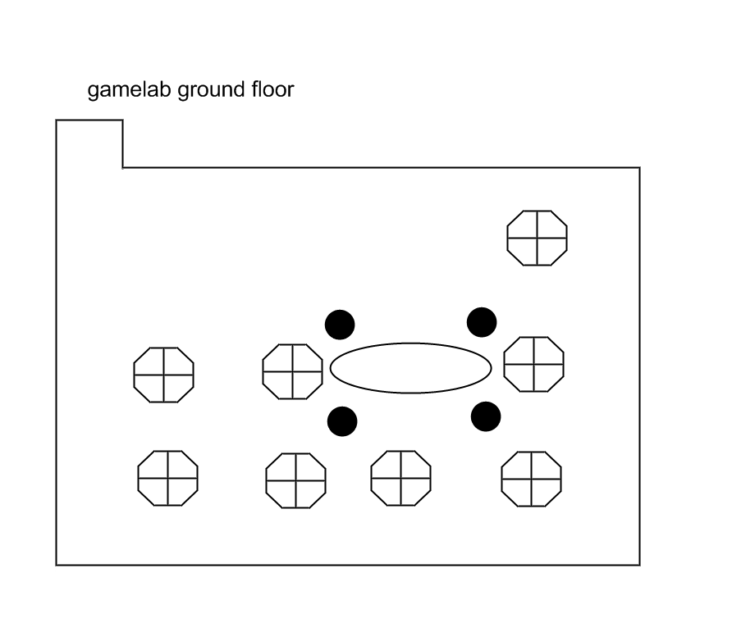

## 4.3 Gamelab first floor

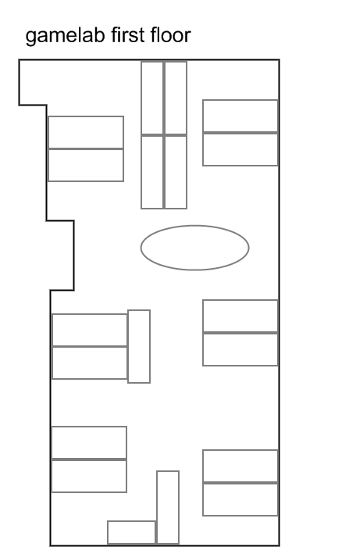

# 5.0 Game Characters

## 5.1 Overview

This game has one hero and one main enemy that is divided in several types.

## 5.2 the main Character

The player plays as Jacco and controls the toy helicopter.

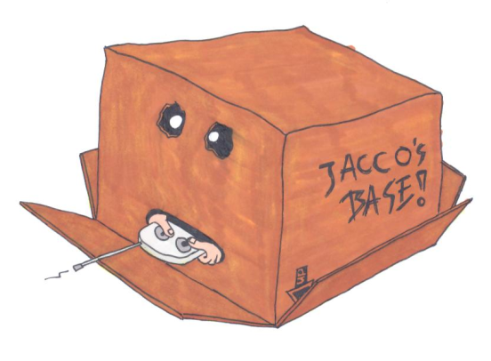

Jacco controls a small toy helicopter and this will be the object the player controls

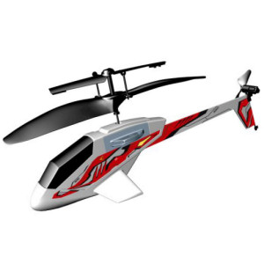

## 5.3 Enemies and Monsters

All of the enemies are ants but there are several types.

*The normal ants*

These ants did not come in contact with the mutating stuff and are not attacking anything.

*The mutated ants*

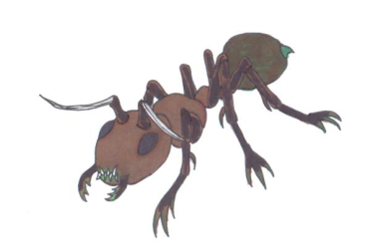

These are the ants that are mutated and attack the player they can do this by spitting acid.

*mutated ants – jumpers*

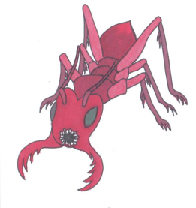

These ants have very large legs and can jump very high.

*Mutated ants – disruptors*

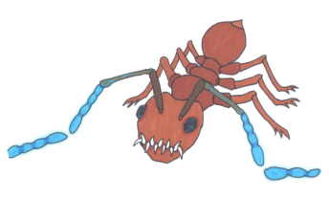

These ants have blue glowing antennae and try to get together with four others of the same kind when they do they form a circle and use there antennas to disrupt the remote control of the helicopter.

*Mutated ants – soldiers*

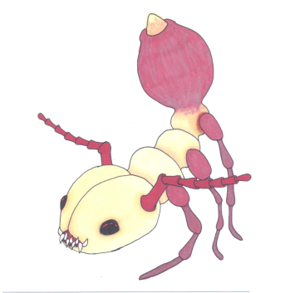

A little bit bigger and a lot stronger then the normal ants these guys will shoot spikes with their tail that they have grown.

*Ant boss*

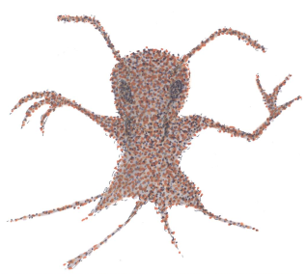

This is the final enemy - allot of mutated ants form together to become one great ant.

# 6.0 User Interface

## 6.1 Overview

Except for the main menu the whole GUI is integrated into the environment this will mean that from the moment the player has entered the game the player won’t see any menu until the player hits the ESC key.

## 6.2 Instruction/Tutorial monitors

The monitors in the game environment are not only part of the scene but are also used for providing the information needed by the player.

Because we use the monitors to provide the information there is no need to have a GUI that states the same thing.

## 6.3 Led indicator

Coffee

To provide the user with information on how much coffee is left in his tank the helicopter will have five led’s on its tail. Each led represents 20% coffee in the tank. The last one will start to blink when its coffee-level is bellow 5% and turn red when the tank is empty.

Staples

On the backside of the small wings led’s will indicate the ammo left for the staple guns

## 6.4 Smoke and fire

When the helicopter is damaged for more then 50% the helicopter will start to emit smoke.

If the helicopter's health becomes lower then 10% fire will start out of the sides.

Also the fact that control of the helicopter is getting worse will alert the player that he needs to find a repair kit.

## 6.5 Laser colour

When the player fetched a battery the power of the laser will increase. To indicate this to the player the laser will change to a different color.

## 6.6 menus

The one menu the game does have provides the following options:

*- when game not in progress*

+start new game

+enter keycode

+set configuration

+exit

*- when game in progress*

+resume

+set configuration

+end game

+exit game

7.0 Weapons

## 7.1 Overview

The helicopter makes use of three kinds of weapons the Coffee Canon, the laser and staple gun.

The cc and laser gun are located at the front of the helicopter and only can be used

## 7.2 Coffee Canon (the C C )

The more powerful of the three weapons is the Coffee Canon, it uses superheated coffee collected from coffee icons to attack the ants. This weapon can be exchanged with the other secondary weapon, the Staple Gun.

<IMAGE HERE>

<ammo types images>

## 7.3 Laser gun

The laser gun is the helicopter's primary weapon it has a power-supply that can’t be drained so this primary weapon is always available.

The laser can be upgraded two times and will visual change accordingly.

<IMAGE HERE>

<upgrade types images>

## 7.4 Staple gun

The Staple gun is the other secondary weapon, this weapon will fire staples at high speed. The supply of staples is limited so the player will have to use this weapon wisely.

<IMAGE HERE>

<ammo types images>

# 8.0 Musical Scores and Sound Effects

## 8.1 Overview

This game will use music and sound effects in a arcade kind of way.

## 8.2 Music

<added in a later version of game design doc>

## 8.3 Sound effects

The sound effects used will be from the BBC sound library

Effects that are needed:

Explosions

Laser fire

Ant sounds

Pickup sounds

Staple gun fire

Coffee gun sound

Toy helicopter sound

<more added later>

# 9.0 Main Game aspects

## 9.1 Overview

This Game will combine the toy helicopter game elements with that of an Ant Wars game. Combining these two games together will create a fun yet challenging game that has combines the fun of controlling a toy helicopter with the objective and mission style game play of an Ant Wars game.

## 9.2 Story( a more detailed description is found in the story appendix )

The story begins when a couple of ants mutate and discover they can use electricity for mutating further. The room in the Blushuis that emits the strongest electrical field is the Gamelab room where Jacco is working. After a few minutes the ants have found a way into Blushuis and up to the Gamelab.

Jacco realizing that he’s not longer alone, looks at the stairs, at that point the ants are climbing upstairs towards the level where the meter cupboard is located.

Jacco realizes that the future of the whole course is now in his hands and quickly crabs his toy helicopter to defend the IGAD course from a save distance.

Jacco knows to drive the ants back to the low level of gamelab when the ants realise that they are losing the battle they combine there efforts and change into a giant ant. Jacco gets into a difficult battle but after a couple of minutes it is clear who is going to win, the ants fall apart and die.

<add more when more levels are added>

Lastly we see Jacco coming out of the Blushuis knowing he has saved the course from an ant attack and calmly goes home to work on his raytracer

End

**9.3 Defeat Conditions**

Player's helicopter is destroyed by the ants.

Ants prevent player from completing an objective.

**9.4 Victory Conditions**

Player completes objectives and defeats the end(ant) boss

# “Story Appendix”

This is a complete storyboard outline:

|  |  |  |
| --- | --- | --- |
| #1-1 | The story begins | Story-mode cam |
| Jacco is working alone on the top floor of game lab.  Frame 1-1 Jacco coming in to Blushuis.  Frame 1-2 Jacco coming in to Gamelab and walking upstairs.  Frame 1-3 Jacco starting to work.  Comic style text :“Another day at the IGAD course started like any other one.”  Comic style text: “Jacco walked up to the classroom to prepare for his classes.”  Comic style text: “Jacco started his work not knowing what would come today. <rewrite>” | | |

|  |  |  |
| --- | --- | --- |
| #2 | Meanwhile | Story-mode cam |
| Frame 1 : Black screen with the text “meanwhile in basement of ” | | |

|  |  |  |
| --- | --- | --- |
| #3 | The explanation | Story-mode cam |
| The reason why the ants have mutated and are attracted is shown in these frames.  Frame 1 -1: Normal ants convey around dumped toxic looking barrels.  Frame 1- 2: Ants mutate.  Frame 1-3: Ants slurping in electricity.  Frame 1-4: Shot of the power management monitor highlighting igad as the top consuming section of Blushuis. | | |

|  |  |  |
| --- | --- | --- |
| #4 | The hero rises | Story-mode cam |
| Jacco gets ready to defend the Blushuis.  Frame 1 -1: Jacco hears something.  Frame 1- 2: Ants coming into Gamelab.  Frame 1-3: Jacco reaching for his helicopter controller. | | |

|  |  |  |
| --- | --- | --- |
| #5 | Objective complete the tutorial. | Tutorial-mode cam |
| Learn how to control the various controls of the helicopter.  (possible to skip) | | |

|  |  |  |
| --- | --- | --- |
| #6 | What the …… | Zoom-cam |
| After the tutorial the cam will change to the game mode cam and the player will see that the top floor of Gamelab is crowed with ants. | | |

|  |  |  |
| --- | --- | --- |
| #7 | Objective: Clear the teacher floor NOW! | Game-cam |
| It becomes clear that the Gamelab floor has to be cleared of ants before the player can focus on the stairs  The objective will be completed when less then< 5%> is of the upstairs ants are alive. | | |

|  |  |  |
| --- | --- | --- |
| #8 | Look at the stairs! | Zoom-cam |
| After the Gamelab top floor has been cleared the camera will zoom at the stairs and show that more ants are coming up. | | |

|  |  |  |
| --- | --- | --- |
| #9 | Objective: What do you need? Guns lots of guns! | Instruction-cam |
| On a nearby monitor the instruction are displayed telling you that you need more ammo and more powerful weapons to clear the stairs , the supply cabinet is a good place to find them. | | |

|  |  |  |
| --- | --- | --- |
| #10 | Ants get everywhere. | Zoom-cam |
| When flying to the (closed) supply cabinet several parts of the doors blow up and ants start to attack. | | |

|  |  |  |
| --- | --- | --- |
| #11 | Get out my cabinet! | Zoom-cam |
| The player have to kill the ants and blow up the rest of the door so he can get the coffee gun and ammo for it. | | |

|  |  |  |
| --- | --- | --- |
| #12 | Objective: The stairs! | Instruction-cam |
| Time to clear the way to the down floor. | | |

|  |  |  |
| --- | --- | --- |
| #13 | None will be spared. | Game-cam |
| Destroy the ants on stairs so you can go downstairs and ensure no ant comes up every again. | | |

|  |  |  |
| --- | --- | --- |
| #14 | Objective: Hear the wind blow | Instruction-cam |
| The air-conditioning installation is making it difficult to fly directly to the door so you get instructions to deactivate it. | | |

|  |  |  |
| --- | --- | --- |
| #15 | Must destroy | Zoom-cam |
| The cam zooms in on the air-conditioning and controls. | | |

|  |  |  |
| --- | --- | --- |
| #16 | Boom | Game-cam |
| Destroy the air-conditioning controls so that the player can fly through the rest of Gamelab. | | |

|  |  |  |
| --- | --- | --- |
| #17 | They just keep on coming | Zoom-cam |
| Again the Gamelab fills with more ants coming from the crack bellow the door. | | |

|  |  |  |
| --- | --- | --- |
| #18 | Objective: Staples to the rescue. | instruction-cam |
| The instructions on a nearby monitor tell the player about a secondary weapon and that you need to find some ammo for it. | | |

|  |  |  |
| --- | --- | --- |
| #16 | Staples and ants do you need any more in life? | Game-cam |
| Kill the ants. | | |

|  |  |  |
| --- | --- | --- |
| #17 | The final call. | Zoom-cam |
| A large group of ants enter the Gamelab and form a giant huge ant. | | |

|  |  |  |
| --- | --- | --- |
| #18 | Objective: Die monster die! | Game-cam |
| Destroy the giant ant boss. | | |

<next room>

|  |  |  |
| --- | --- | --- |
| #19 | The fat lady sings. | Story mode cam |
| Jacco has beaten the ants and returns home.  Frame 1-1 Jacco putting the controller down.  Frame 1-2 Jacco lighting up a smoke.  Frame 1-3 Jacco walking away.  Comic style text :“It is over.”  Comic style text: “The IGAD course is save. ”  Comic style text: “But for how long???...” | | |

|  |  |  |
| --- | --- | --- |
| #20 | Credits | Story mode cam |
| Credits | | |